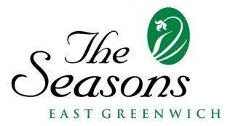

At The Seasons East Greenwich, we value our employees and believe that
work-life balance is essential to employee well-being.
Benefits for our regular employees include the following:

Health and Wellness Benefits:
- Medical
- Dental
- Vision
- HRA
- FSA
- Supplemental
- Life Insurance
Paid days off:
- Vacation
- Sick
- Personal
- Birthday
- Holidays
403(B) Retirement Plan with employer match
Additional Benefits:
- Direct Deposit
- Free meal during shift
- Employee Assistance Program (EAP)

Specific benefits vary based on longevity with The Seasons and employent type (full-time vs
part-time). The company reserves the right to amend, delete or add any benefit plans.

