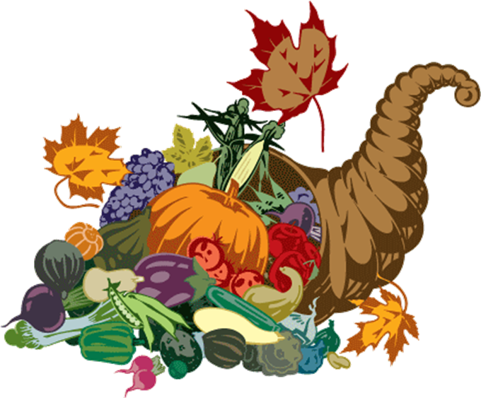
ASPECTS OF LIVING   Cognitive   Musical   Life Experiences   Reminisce   Health & Fitness   Inspirational/Emotional   Social |  | DAILY PROGRAMS  Unless otherwise noted   9:15 Positive Current Events   10:30 AM Snack   11:00 Feeding of the Fish/  Garden Group   1:00 Daily Chronicles    2:30 Snack & Social    5:15 Mindful Unwind    5:45 Movie/Classic Series |  |   GRANDVIEW GARDENS 2024 |  |  |  10:00 AM Exercise   10:45 Scenic Ride   11:15 Guess the Word    1:45 Ring Toss    Relaxation to Music      3:15 Seated Yoga    3:45 Finish the Line |  10:00 Wake-up & Workout   11:15 Table Top Curling    Comedy & Laughter    1:45 Pumpkin Toss    Music & Relaxation    3:15 Afternoon Stretch        Rosary    3:45 Music & Meditation
 10:15 Communion w/ OLM   10:30 Hymnals & Snack   11:00 Get up & Move   1:30 Afternoon Stretch    2:00 Worship Service w/ Com.   Color Artistry/Puzzles    3:15 Balloon Bash    Music & Reminisce    4:00 Brain Games |  10:00 Wake up & Zumba   11:15 Bean Bag Toss   Color Artistry/Puzzles    1:45 Floor Bulls-eye   Helping Hands    3:15 Afternoon Exercise    Short Stories    3:45 Meditation & Reflection |  | ELECTION DAY   10:00 Wake-up & Workout   11:15 Tic Tac Toe Toss         Mosaic Puzzles    1:30 Ride and Reminisce    Nail Care    2:00 Trivia…Did you Know   3:15 Music Sing Along   3:45 Afternoon Stretch   Audio Book Club |  |  10:00 Wake up & Zumba   11:15 Table Top Darts         Brain Games     1:45 Balloon Volley     Color Artistry    3:15 Seated Yoga     Nail Care & Reminisce    3:45 Who Sings It? |  10:00 Wake-up & Workout   11:15 Word Chains    1:30 Quarterback Toss         Kitchen Creations:  Pumpkin Pie    2:00 Name that Tune    3:15 Afternoon Stretch    Puzzles    3:45 Mindful Mediation |  10:00 AM Exercise   10:45 Scenic Ride   11:15 Guess the Word    1:45 Ring Toss    Relaxation to Music     3:15 Seated Yoga    3:45 Finish the Line |  10:00 Wake-up & Workout   11:15 Table Top Curling    Comedy & Laughter    1:45 Pumpkin Toss    Music & Relaxation    3:15 Afternoon Stretch        Rosary    3:45 Music & Meditation
 9:30 Morning Stretch   10:15 Communion w/ OLM   10:30 Snack & Hymns   11:15 Virtual Church Service    Nail Care & Tunes   1:30 Sunday Ride        Color Artistry/Puzzles    3:15 Chair-Aerobics    Music & Reminisce    3:45 Uplifting Stories | VETERAN’S DAY   10:15 Wake up & Zumba   11:00 Veterans Day Special (YT)  A Celebration of Our Nation's Military Branches | Drive Thru History Special    1:30 Bean Bag Toss   2:30 Munchies and Live Music          w/ Bob Trembley    3:15 Afternoon Exercise    3:45 Meditation & Reflection |  |  10:00 Wake-up & Workout   11:15 Tic Tac Toe Toss         Mosaic Puzzles    1:30 Ride and Reminisce    Nail Care    2:00 Trivia…Did you Know   3:15 Music Sing Along   3:45 Afternoon Stretch   Audio Book Club |  |  10:00 Wake up & Zumba   11:15 Table Top Darts         Brain Games     1:45 Balloon Volley     Color Artistry    3:15 Seated Yoga     Nail Care & Reminisce    3:45 Who Sings It? |  10:00 Wake up & Zumba   11:15 Table Top Darts         Brain Games     1:45 Balloon Volley     Color Artistry    3:15 Seated Yoga     Nail Care & Reminisce    3:45 Who Sings It? |  10:00 AM Exercise   10:45 Scenic Ride   11:15 Guess the Word    1:45 Ring Toss    Relaxation to Music     3:15 Seated Yoga    3:45 Finish the Line |  10:00 Wake-up & Workout   11:15 Table Top Curling    Comedy & Laughter    1:45 Pumpkin Toss    Music & Relaxation    3:15 Afternoon Stretch        Rosary    3:45 Music & Meditation
 9:30 Morning Stretch   10:15 Communion w/ OLM   10:30 Snack & Hymns   11:15 Virtual Church Service    Nail Care & Tunes   1:30 Football Toss    3:15 Chair-Aerobics    Music & Reminisce    3:45 Uplifting Stories |  10:00 Wake up & Zumba   11:00 Music w/ Mike Coletta  1:30 Catholic Mass on AL Community    1:45 Floor Bulls-eye    3:15 Afternoon Exercise    Short Stories    3:45 Meditation & Reflection |  |  10:00 Wake-up & Workout   11:15 Bean Bag Toss         Mosaic Puzzles    1:30 Reminisce    Nail Care    2:00 Chaplain Chat  w/ Rev. Cheryl   3:15 Music Sing Along   3:45 Afternoon Stretch   Audio Book Club |  |  10:00 Wake up & Zumba   11:15 Table Top Darts         Brain Games     1:45 Balloon Volley     Color Artistry    3:15 Seated Yoga     Nail Care & Reminisce    3:45 Who Sings It? |  10:00 Wake up & Zumba   11:15 Table Top Darts         Brain Games     1:45 Balloon Volley     Color Artistry    3:15 Seated Yoga     Nail Care & Reminisce    3:45 Who Sings It? |  10:00 AM Exercise   10:45 Scenic Ride   11:15 Guess the Word    1:45 Ring Toss    Relaxation to Music     3:15 Seated Yoga    3:45 Finish the Line |  10:00 Wake-up & Workout   11:15 Table Top Curling    Comedy & Laughter    1:45 Pumpkin Toss    Music & Relaxation    3:15 Afternoon Stretch        Rosary    3:45 Music & Meditation
 9:30 Morning Stretch   10:15 Communion w/ OLM   10:30 Snack & Hymns   11:15 Virtual Church Service    Nail Care & Tunes   1:30 Sunday Ride        Color Artistry/Puzzles    3:15 Chair-Aerobics    Music & Reminisce    3:45 Uplifting Stories |  10:00 Wake up & Zumba   11:15 Bean Bag Toss   Color Artistry/Puzzles    1:45 Floor Bulls-eye   Helping Hands: Sorting    3:15 Afternoon Exercise    Short Stories    3:45 Meditation & Reflection |  |  10:00 Wake-up & Workout   11:15 Tic Tac Toe Toss         Mosaic Puzzles    1:30 Travel Petting Farm    2:00 Trivia…Did you Know   3:15 Music Sing Along   3:45 Afternoon Stretch   Audio Book Club |  |  10:00 Wake up & Zumba   11:15 Table Darts         Mosaic Puzzles    1:30 Tap’n Time w/ Belle     Color Artistry    3:15 Seated Yoga     Nail Care & Reminisce    3:45 Who Sings It? | THANKSGIVING DAY    9:00 Macy’s Parade   10:15 Wake up & Zumba   11:15 Thanksgiving Trivia    1:45 Balloon Volley     Holiday Movies in Den    3:15 Seated Yoga & Gratitude    3:45 Sing Along |  10:00 AM Exercise   10:45 Armchair Travel   11:15 Guess the Word    1:45 Ring Toss    2:30 Music & Munchies  w/ Don & Dave    3:15 Seated Yoga    3:45 Finish the Line |  10:00 Wake-up & Workout   11:15 Table Top Curling    Comedy & Laughter    1:45 Pumpkin Toss    Music & Relaxation    3:15 Afternoon Stretch        Rosary    3:45 Music & Meditation
Subject to change: Daily Schedules Made Available & Displayed in Community All outings are weather permitting MEAL TIMES: 12:00-1:00p; 4:30-5:30p
Sunday | Monday | Tuesday | Wednesday | Thursday | Friday | Saturday
 |  |  |  |  | 1 | 2
3 | 4 | 5 | 6 | 7 | 8 | 9
10 | 11 | 12 | 13 | 14 | 15 | 16
17 | 18 | 19 | 20 | 21 | 22 | 23
24 | 25 | 26 | 27 | 28 | 29 | 30

